Mutual information: GBPUSD and USDCHF
Method 15 / daily log returns / B=10 equal-frequency bins / Alpari D1 full available history

Study setup
Logical pair: GBPUSD , USDCHF
Broker symbols: GBPUSD_i , USDCHF_i
Snapshot: 2026-11-03_majors_alpari_D1
Timeframe: D1
Matched return window: 1999-01-05 to 2026-11-02 (UTC bar dates)
Matched return count n: 7201
Dropped unfinished last bar dated 2026-11-03 UTC after a tick-volume check against the prior complete day.
Discretization: B=10 equal-frequency bins per leg
Units: nats (natural log)
Complete matched rows (Excel): GBPUSD-USDCHF_MI_D1.xlsx
Complete matched rows (HTML table): GBPUSD-USDCHF_MI_D1_data.html

Method carried forward
Mutual information I(X;Y) measures shared information between matched daily log returns of close, ln(close_t / close_t-1), after a fixed discretization. Quotes are not inverted. Each leg is cut into B=10 equal-frequency (decile) bins using that leg's matched-sample quantiles. Discrete MI uses natural log (nats): I = sum p_ab ln(p_ab / (p_a p_b)). Marginal entropies H_x and H_y and normalized MI = I / sqrt(H_x H_y) are stored for comparison. Bin count is not tuned after seeing pair rankings. Same-sample Pearson r is a side check only. This is not causation, lead-lag, or a trading signal.

Results
I(X;Y): 0.200400 nats
Normalized MI: 0.087033
H_x: 2.302585
H_y: 2.302585
Same-sample Pearson r: -0.486083

Conclusion
Over 7201 matched daily rows for GBPUSD and USDCHF with B=10 equal-frequency bins, I(X;Y) = 0.200400 nats (normalized MI = 0.0870; H_x=2.3026, H_y=2.3026). Same-sample Pearson r is -0.4861. This does not establish cause, lead-lag, or a lasting trading rule.

Charts
Daily closes

Daily log returns

Joint bin-count heatmap
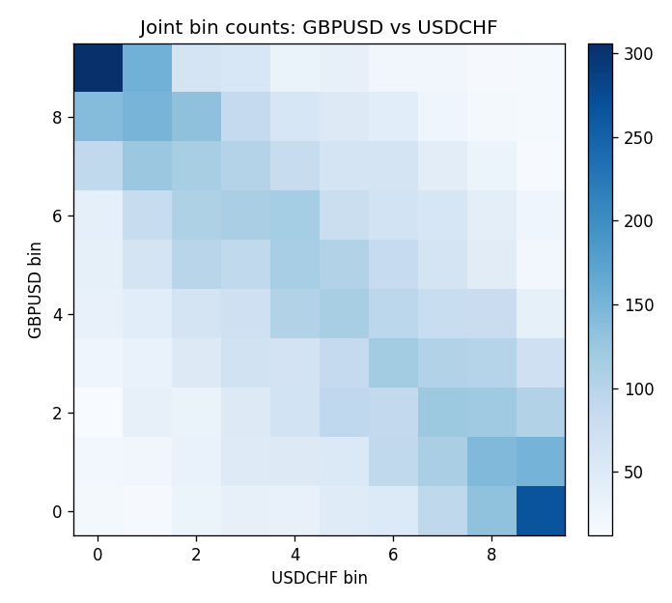

Data report
Every matched row that entered MI is stored in the sibling Excel workbook named GBPUSD-USDCHF_MI_D1.xlsx, including bin labels. Embedding all rows as a Word table is impractical; this file holds column summaries and the first and last 15 matched rows.
Columns: time, GBPUSD_open, USDCHF_open, GBPUSD_high, USDCHF_high, GBPUSD_low, USDCHF_low, GBPUSD_close, USDCHF_close, GBPUSD_tick_volume, USDCHF_tick_volume, GBPUSD_spread, USDCHF_spread, GBPUSD_real_volume, USDCHF_real_volume, GBPUSD_log_return, USDCHF_log_return, GBPUSD_bin, USDCHF_bin
Column summaries (matched calculation rows)
column | count | mean | std | min | 25% | 50% | 75% | max
GBPUSD_open | 7201 | 1.5160785 | 0.218271 | 1.06854 | 1.32499 | 1.51142 | 1.63167 | 2.1066
USDCHF_open | 7201 | 1.0982956 | 0.25264095 | 0.72022 | 0.92069 | 0.99019 | 1.2387 | 1.8219
GBPUSD_high | 7201 | 1.5223771 | 0.21884011 | 1.08366 | 1.32979 | 1.5182 | 1.6384 | 2.1161
USDCHF_high | 7201 | 1.1035944 | 0.25438893 | 0.73305 | 0.92495 | 0.99377 | 1.2436 | 1.8313
GBPUSD_low | 7201 | 1.5097512 | 0.21749696 | 1.03518 | 1.31949 | 1.50336 | 1.6244 | 2.0983
USDCHF_low | 7201 | 1.0931703 | 0.25105533 | 0.08565 | 0.91742 | 0.9867 | 1.2331 | 1.8121
GBPUSD_close | 7201 | 1.5161456 | 0.2182303 | 1.06879 | 1.3251 | 1.5114 | 1.63212 | 2.1065
USDCHF_close | 7201 | 1.0982864 | 0.25254184 | 0.72025 | 0.92098 | 0.9902 | 1.2387 | 1.8217
GBPUSD_tick_volume | 7201 | 94828.085 | 153546.21 | 62 | 10002 | 52900 | 91806 | 1273370
USDCHF_tick_volume | 7201 | 74189.26 | 113409.95 | 18 | 12770 | 40195 | 70240 | 858589
GBPUSD_spread | 7201 | 26.971115 | 19.193539 | 0 | 11 | 20 | 50 | 50
USDCHF_spread | 7201 | 26.114567 | 24.723753 | 0 | 5 | 16 | 50 | 100
GBPUSD_real_volume | 7201 | 3.5560898e+09 | 8.4438214e+10 | 0 | 0 | 0 | 0 | 2.4038164e+12
USDCHF_real_volume | 7201 | 2.3236557e+10 | 8.9041498e+10 | 0 | 0 | 0 | 0 | 1.9331921e+12
GBPUSD_log_return | 7201 | -2.316e-05 | 0.00564524 | -0.08388241 | -0.00312969 | 3.242e-05 | 0.00318104 | 0.03112653
USDCHF_log_return | 7201 | -7.148e-05 | 0.00659332 | -0.19545699 | -0.00335964 | 8.06e-05 | 0.00331782 | 0.09051364
GBPUSD_bin | 7201 | 4.5006249 | 2.8727708 | 0 | 2 | 5 | 7 | 9
USDCHF_bin | 7201 | 4.5006249 | 2.8727708 | 0 | 2 | 5 | 7 | 9
First 15 matched rows (selected columns)
time | GBPUSD_close | USDCHF_close | GBPUSD_log_return | USDCHF_log_return | GBPUSD_bin | USDCHF_bin
1999-01-05 | 1.6547 | 1.3724 | -0.0028966287 | 0.0039424743 | 2 | 7
1999-01-06 | 1.6537 | 1.3912 | -0.00060452184 | 0.013605652 | 4 | 9
1999-01-07 | 1.6502 | 1.3782 | -0.002118709 | -0.0093883841 | 3 | 0
1999-01-08 | 1.6405 | 1.3935 | -0.0058954193 | 0.011040268 | 1 | 9
1999-01-11 | 1.6312 | 1.4009 | -0.0056851331 | 0.0052963193 | 1 | 8
1999-01-12 | 1.6349 | 1.3872 | 0.0022657001 | -0.0098275602 | 6 | 0
1999-01-13 | 1.6499 | 1.3621 | 0.0091330396 | -0.018259701 | 9 | 0
1999-01-14 | 1.6531 | 1.3588 | 0.0019376331 | -0.0024256692 | 6 | 3
1999-01-15 | 1.6502 | 1.3834 | -0.0017558204 | 0.01794228 | 3 | 9
1999-01-18 | 1.6522 | 1.379 | 0.0012112405 | -0.0031856384 | 6 | 2
1999-01-19 | 1.6553 | 1.3789 | 0.0018745281 | -7.2518946e-05 | 6 | 4
1999-01-20 | 1.6472 | 1.3889 | -0.0049053846 | 0.0072259871 | 1 | 9
1999-01-21 | 1.6524 | 1.3836 | 0.0031518998 | -0.0038232689 | 7 | 2
1999-01-22 | 1.6565 | 1.3834 | 0.0024781662 | -0.0001445609 | 7 | 4
1999-01-25 | 1.6585 | 1.3868 | 0.0012066366 | 0.0024546976 | 6 | 6
Last 15 matched rows (selected columns)
time | GBPUSD_close | USDCHF_close | GBPUSD_log_return | USDCHF_log_return | GBPUSD_bin | USDCHF_bin
2026-10-13 | 1.32534 | 0.83244 | 0.0036434319 | -0.0024955621 | 7 | 3
2026-10-14 | 1.31884 | 0.83489 | -0.0049164679 | 0.0029388325 | 1 | 7
2026-10-15 | 1.32757 | 0.82676 | 0.0065976411 | -0.0097855323 | 9 | 0
2026-10-16 | 1.33257 | 0.82377 | 0.0037592051 | -0.0036230826 | 7 | 2
2026-10-19 | 1.33024 | 0.82677 | -0.0017500314 | 0.0036351779 | 3 | 7
2026-10-20 | 1.3377 | 0.8246 | 0.0055923442 | -0.0026281224 | 8 | 2
2026-10-21 | 1.33937 | 0.82427 | 0.0012476328 | -0.00040027413 | 6 | 4
2026-10-22 | 1.33967 | 0.82032 | 0.00022396082 | -0.0048036381 | 5 | 1
2026-10-23 | 1.33684 | 0.82497 | -0.0021146949 | 0.005652514 | 3 | 8
2026-10-26 | 1.33359 | 0.82649 | -0.0024340661 | 0.0018407959 | 2 | 6
2026-10-27 | 1.33044 | 0.82865 | -0.0023648393 | 0.0026100526 | 3 | 7
2026-10-28 | 1.33254 | 0.82781 | 0.0015771808 | -0.0010142111 | 6 | 4
2026-10-29 | 1.33733 | 0.82379 | 0.0035881935 | -0.0048680164 | 7 | 1
2026-10-30 | 1.33913 | 0.82438 | 0.0013450605 | 0.00071594559 | 6 | 5
2026-11-02 | 1.3406 | 0.81851 | 0.0010971256 | -0.0071459744 | 5 | 1

